**Aerospace Toolbox**

Analyze and visualize aerospace vehicle motion using reference standards and models

**Note:** Fixed-Wing Aircraft Creation with Functions requires **R2021b**.

**CONTENTS**

**1.** **Introduction** 2

**2.** **Features** 2

*2.1.* *Control and Stability Analysis* 2

*2.2.* *Satellite Mission Analysis* 2

*2.3.* *Vehicle Motion Analysis* 2

*2.4.* *Environmental Models* 2

*2.5.* *Visualize Trajectory and Attitude* 2

**3.** **Fixed-Wing Aircraft Applications** [1] 2

*3.1.* *Configuration: Function* ***fixedWingAircraft*** 2

*3.2.* *Numerical Modeling: Function* ***fixedWingCoefficient*** 2

*3.3.* *States: Function* ***fixedWingState*** 3

*3.4.* *DATCOM (Data Compendium)* 3

**4.** **Example** 5

*4.1.* *Determine Nonlinear Dynamics and Static Stability of Fixed-Wing Aircraft* [5] 5

*4.2.* *Analyze State-Space Model for Linear Control and Static Stability Analysis* 7

*4.3.* *Lightweight Airplane Design* [7] 7

References 8

# **Introduction**

Aerospace Toolbox provides standards-based tools and functions for analyzing the motion, mission, and environment of aerospace vehicles. It includes aerospace math operations, coordinate system and spatial transformations, and validated environment models for interpreting flight data.

# **Features**

## [*Control and Stability Analysis*](https://www.mathworks.com/help/aerotbx/reference-applications.html)

## [*Satellite Mission Analysis*](https://www.mathworks.com/help/aerotbx/satellite-mission-analysis.html)

## [*Vehicle Motion Analysis*](https://www.mathworks.com/help/aerotbx/vehicle-motion-analysis.html)

## [*Environmental Models*](https://www.mathworks.com/help/aerotbx/environmental-models-1.html)

## [*Visualize Trajectory and Attitude*](https://www.mathworks.com/help/aerotbx/view-simulation-results.html)

# **Fixed-Wing Aircraft Applications** [1]

## *Configuration: Function* ***fixedWingAircraft***

Constructs a basic 3-control surface, standard-configuration aircraft.

aircraft =

FixedWing with properties:

ReferenceArea: 3

ReferenceSpan: 2

ReferenceLength: 1

Coefficients: [1x1 Aero.FixedWing.Coefficient]

DegreesOfFreedom: "6DOF"

Surfaces: [1x0 Aero.FixedWing.Surface]

Thrusts: [1x0 Aero.FixedWing.Thrust]

AspectRatio: 1.3333

Properties: [1x1 Aero.Aircraft.Properties]

UnitSystem: "Metric"

TemperatureSystem: "Kelvin"

AngleSystem: "Radians"

## *Numerical Modeling: Function* ***fixedWingCoefficient***

 Aircraft coefficients are the fixed set of coefficients that define body forces and moments, excluding reaction forces due to control surfaces or thrust vectors.

If using Digital DATCOM, directly convert the Digital DATCOM struct to a fixed-wing aircraft using **datcomToFixedWing**. Coefficients also can be manually import.

Function ***fixedWingCoefficient***:

Table 1. Reference frame for coefficients

| **Ref Frame** | **Coefficient Out** | **Ref Frame** | **Coefficient Out** | **Ref Frame** | **Coefficient Out** |
| --- | --- | --- | --- | --- | --- |
| **Wind** | Forces:   * drag (CD) * Y (CY) * lift (CL) | **Body** | Forces:   * X (CX) * Y (CY) * Z (CZ) | **Stability** | Forces:   * drag (CD) * Y (CY) * lift (Cn) |
| Moments:   * L (Cl) * M (Cm) * N (Cn) | Moments:   * L (Cl) * M (Cm) * N (Cn) | Moments:   * L (Cl) * M (Cm) * N (Cn) |

## *States: Function* ***fixedWingState***

Include the mass, inertia, airspeed, altitude, deflection angles, and others.

Define the current flying environment using the **aircraftEnvironment** function.

## *DATCOM (Data Compendium)*

USAF Digital Datcom (United States Air Force Stability and Control Digital DATCOM) computer program is an approach to provide rapid and economical estimation of aerodynamic stability and control characteristics.

1. Control DATCOM

From [2], fundamentally, the purpose of the Datcom is to provide a systematic summary of methods for estimating basic stability and control derivatives. The Datcom is organized in such a way that it is self-sufficient. For any given flight condition and configuration, the complete set of derivatives can be determined without resorting to outside information. Method to be used for preliminary design purposes before the acquisition of test data. The use of reliable test data instead of the Datcom is always recommended. However, there are many cases where the Datcom can be used to advantage in conjunction with test data.

1. Digital DATCOM

Digital Datcom calculates static stability, high-lift and control device, and dynamic derivative characteristics using the methods provided in [2]. The computer program also offer a trim option that computes control deflections and aerodynamic data for vehicle trim at subsonic Mach numbers. The users manual is available in [3].

1. Addressable Configurations

|  |  |  |
| --- | --- | --- |
| **Configuration** | **Program Remark** | **Illustration** |
| BODY | Primarily bodies of ***revolution***, or close approximations are treated. | Strake (aeronautics) - Wikipedia  Canard-and main wing-fuselage fairings. | Download Scientific Diagram  5 Aerodynamic Facts Pilots Should Know About Flaps | Boldmethod |
| WING, HORIZOTAL TAIL | Straight tapered, cranked,or double delta planforms are treated. Effects of sweep, taper and incidence are included. Linear twist is treated at subsonic Mach numbers. Dihedral effects are present in the lateral directional data. |
| BODY-WING, BODY-HORIZONTAL | Longitudinal methods reflect only a mid-wing position. Lateral directional solutions consider high and low-wing positions. |
| WING-BODY-TAIL | Various geometry combinations are possible. Wing downwash methods are restricted to straight tapered planforms. Effects of twin vertical tails are included in the static lateral directional data at subsonic Mach numbers. |
| NON_STANDARD GEOMETRIES | Non-standard configurations are simulated using "basic" configuration techniques. Strakes can be run via a double-delta wing. A body-canard-wing is input as a wing-body-horizontal tail. The forward lifting surface is input as a wing and the aft surface as a horizontal tail. |
| SPECIAL CONFIGURATION | Low aspect ratio wing or wing-body configurations (lifting bodies) are treated at subsonic speeds. Two-dimensional flap and transverse jet effects are also treated at hypersonic speeds. |

1. Input file

The basis data unit is ***base***, set of input data that defines a configuration and flight conditions. The cases consist of 4 groups as follows:

* Group 1: Flight conditions and reference dimensions
* Group 2: basis configuration geometry for common object, defining the body, wing, tail surfaces and their relative locations.
* Group 3: special additional configurations such as engines, flaps, control tabs, ground effects or twin vertical panels.
* Group 4: special options, or to obtain extra output.

The computer program is written in the Fortran IV language.

1. Output file
2. Example: Modeing Mig-17

For document [4], the Mig-17 is modeled. The input file constructs following fields:

* **CASEID:**

CASEID MIKOYAN-GUREVICH MiG-17

* **FLTCON** - defines the flight conditions.

$FLTCON NMACH=1.0,MACH(1)=0.6,NALPHA=10.0,ALSCHD(1)=-4.0,-2.0,0.0,2.0,4.0,6.0,8.0,10.0,12.0,14.0,NALT=1.0,ALT(1)=5000.0, WT=13395.0,LOOP=1.$

* **SYNTHS** - locates the cg, wing, horizontal tail, and vertical tail with respect to a reference line.

$SYNTHS XCG=11.17,ZCG=0.0,XW=3.63,ZW=0.42,ALIW=1.0,XH=28.73, ZH=5.24,ALIH=0.0,XV=18.3,ZV=0.0$

* **BODY** - defines the body geometry.

$BODY NX=8.0,

X(1)=0.0,0.74,8.35,13.14,19.35,24.41,28.41,30.77,

S(1)=5.19,9.32,16.89,16.89,15.94,11.12,5.85,2.5$

* **WGPLNF** - defines the wing planform geometry.

$WGPLNF CHRDTP=7.02,SSPNOP=11.32,SSPNE=13.41,SSPN=15.71,CHRDBP=8.4,CHRDR=14.0,SAVSI=45.0,SAVSO=45.0,CHSTAT=0.25,TWISTA=0.0,DHDADI=-3.0,TYPE=1.0$

* **HTPLNF** - defines horizontal tail geometry.

$HTPLNF CHRDTP=1.86,SSPNE=5.42,SSPN=5.43,CHRDR=4.69,SAVSI=45.0,CHSTAT=0.25,TYPE=1.0$

* **VTPLNF** - defines vertical tail geometry.

$VTPLNF CHRDTP=3.76,SSPNE=6.05,SSPN=8.18,CHRDR=12.47,SAVSI=55.0,CHSTAT=0.25,TYPE=1.0$

## *Block in Simulink*

1. Environment

Simulate aspects of environment, such as atmospheric conditions, gravity, magnetic fields, wind.

*Atmosphere*: Implement general atmospheric profiles such as ISA, COESA; nonstandard day simulations; lapse rate atmosphere; pressure altitude.

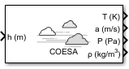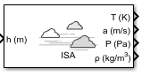Pressure Altitude block

Figure 1. COESA Atmosphere Model, ISA Atmosphere Model, Pressure Altitude, resp.

*Gravity:* Calculate gravity and magnetic fields for any point on Earth.

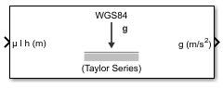

Figure 2. WGS84 Gravity Model, World Magnetic Model, resp.

*Wind:* Implement wind-related simulations, such as turbulence, gust, shear, horizontal wind.

1. Aerodynamics

Compute aerodynamic forces and moments using aerodynamic coefficients, dynamic pressure, center of gravity, center of pressure.

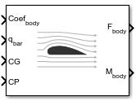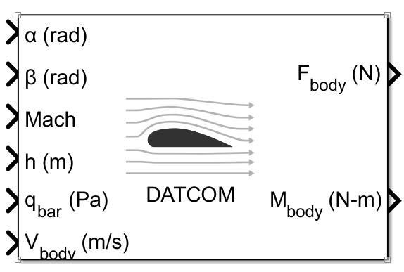

Figure 3. Aerodynamic Forces and Moments, Digital DATCOM Forces and Moments, resp.

1. Equation of Motion

*3DOF*: Implement three-degrees-of-freedom equations of motion in simulations, including custom variable mass models.

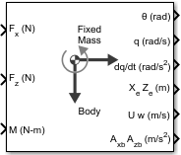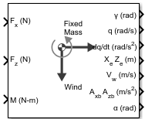

Figure 4. 3DOF (Body, Wind, resp.)

1. GNC

[*Guidance*](https://www.mathworks.com/help/aeroblks/guidance.html): Calculate range between two vehicles

[*Navigation*](https://www.mathworks.com/help/aeroblks/navigation.html): Implement three-axis measurement of accelerations, angular rates, inertias. The Three-Axis Inertial Measurement Unit (IMU) block is typically used to model the behavior of IMU sensors in dynamic systems simulations.

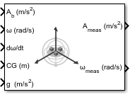

Figure 5. Three-Axis Inertial Measurement Unit (IMU)

[*Control*](https://www.mathworks.com/help/aeroblks/control.html): Simulate various controllers, such as one-dimensional, two-dimensional, three-dimensional types

[*Actuators*](https://www.mathworks.com/help/aeroblks/actuators.html): Represent linear and nonlinear actuators with saturation and rate limits (linear and nonlinear second-order).

1. FlightGear Animation

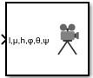

Figure 6. FlightGear Preconfigured 6DoF Animation

# **Example**

## *Determine Nonlinear Dynamics and Static Stability of Fixed-Wing Aircraft* [5]

**Creating and analyzing** a fixed-wing aircraft taken from [6] in MATLAB® using **Cessna C182 geometry** and **coefficient** data.

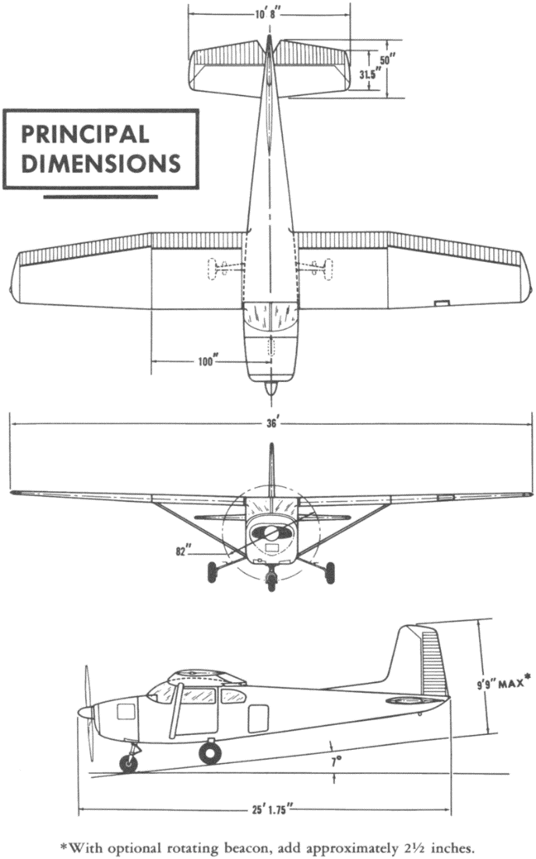 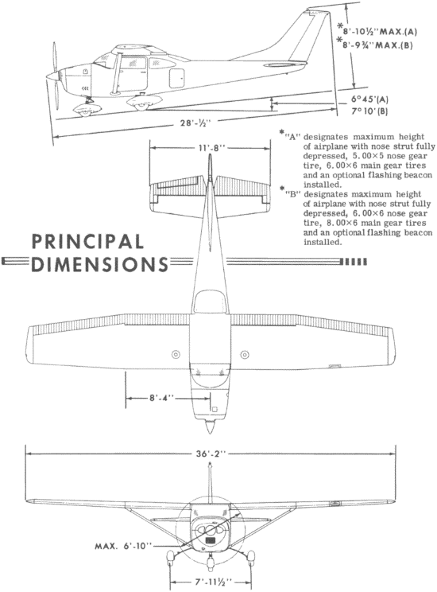

Figure 7. 3-view line drawing of the Cessna 182B, 182M Skylane

1. Setting Up Fixed-Wing Aerodynamic and Control Surfaces.

Create the elevator, ailerons, rudder, horizontal, wing, and vertical stabilizer, resp.

Example for aileron and wing stabilizer:

aileron = fixedWingSurface("Aileron", "on", "Asymmetric", [-20,20], ...

"Coefficients", fixedWingCoefficient("Aileron"));

wing = fixedWingSurface("Wing","Surfaces", aileron);

1. Defining Propulsion

propeller = fixedWingThrust("Propeller","Coefficients", fixedWingCoefficient("Propeller"))

1. Constructing the Aircraft

With the aerodynamic surfaces, control surface, and thrust components defined, define the full aircraft.

C182Properties = Aero.Aircraft.Properties(...

"Name" , "Cessna C182", ...

"Type" , "General Aviation", ...

"Version" , "1.0", ...

"Description", "Cessna 182 Example")

C182 = Aero.FixedWing(...

"Properties" , C182Properties, ...

"UnitSystem" , "English (ft/s)", ...

"AngleSystem" , "Radians", ...

"TemperatureSystem", "Fahrenheit", ...

"ReferenceArea" , 174, ...

"ReferenceSpan" , 36, ...

"ReferenceLength" , 4.9, ...

"Surfaces" , [wing, horizontalStabilizer, verticalStabilizer], ...

"Thrusts" , propeller)

1. Setting the Aircraft Coefficients

These coefficients describe the dynamic behavior of the aircraft. This example defines scalar constant coefficients, which define the linear behavior of the aircraft.

1. Defining the Current State
2. Setting Up the Control States
3. Performing Numerical Analysis

***Forces and Moments***: forcesAndMoments

***Nonlinear Dynamics***: nonlinearDynamics

***Static Stability****:* staticStability

## *Analyze State-Space Model for Linear Control and Static Stability Analysis*

Import the **DATCOM** output file using **datcomimport**:

Then, with the missing data filled, the fixed-wing aircraft can be constructed.

## *Lightweight Airplane Design* [7]

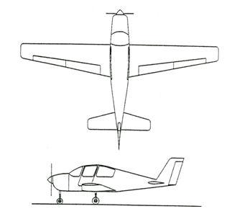

Figure 8. Lightweight four-seater monoplane

A typical plant model includes the following components:

* **Equations of motion**: Calculate vehicle position and attitude from forces and moments.
* **Forces and moments**: Calculate aerodynamic, gravity, and thrust forces and moments.
* **Actuator positions**: Calculate displacements based on actuator commands.
* **Environment**: Include environmental effects of wind disturbances, gravity, and atmosphere.
* **Sensors**: Model the behavior of the measurement devices.

Figure 9. Top Level of Lightweight Aircraft Model

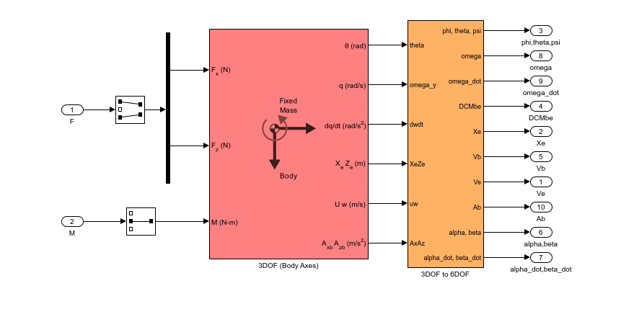

Figure 10. Equations of Motion implemented using 3DoF Euler block from the Aerospace Blockset library.

Figure 11. Aerodynamic Forces and Moments implemented in part with the Aerospace Blockset Digital Datcom Forces and Moment block.

Figure 12. Implementation of actuator models using Aerospace Blockset blocks.

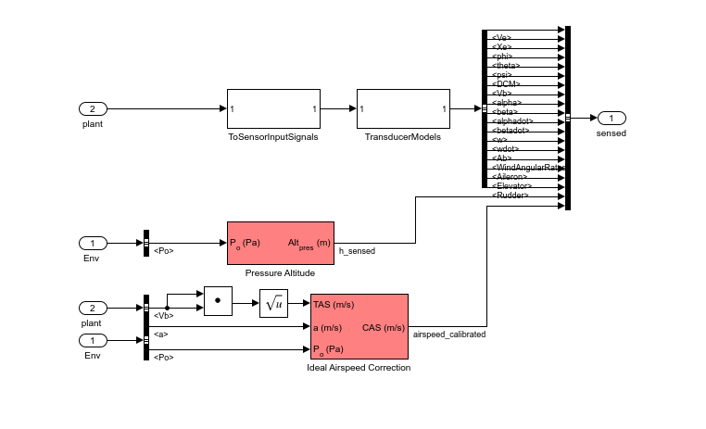

Figure 13. Implementation of flight sensor model using Aerospace Blockset blocks.

Figure 14. Environmental effects of wind, atmosphere, and gravity using Aerospace Blockset blocks.

Figure 15. Longitudinal controller in Simulink model.

# References

|  |  |
| --- | --- |
| [1] | "Get Started with Fixed-Wing Aircraft," MathWorks, [Online]. Available: https://www.mathworks.com/help/aerotbx/ug/Get-Started-With-Fixed-Wing-Aircraft.html. |
| [2] | R. Fink, USAF Stability and Control DATCOM, Ohio: Flight Controls Division, Air Force Flight Dynamics Laboratory, 1978. |
| [3] | The USAF Stability And Control Digital Datcom, vol. 1. |
| [4] | "DATCOM Beginner’s Tutorial," [Online]. Available: http://wpage.unina.it/agodemar/DSV-DQV/DATCOM_Tutorial_I.pdf. |
| [5] | "Determine Nonlinear Dynamics and Static Stability of Fixed-Wing Aircraft," [Online]. Available: https://www.mathworks.com/help/aerotbx/ug/determine-nonlinear-dynamics-and-static-stability-fixed-wing-aircraft.html#mw_rtc_StaticStabilityOfFixedWingAircraftExample_EDAC0EF9. |
| [6] | J. Roskam, Airplane Flight Dynamics and Automatic Flight Controls (Part 1), DAR Corporation, 2003. |
| [7] | "Lightweight Airplane Design," [Online]. Available: https://www.mathworks.com/help/aeroblks/lightweight-airplane-design.html. |